Assignment 5

1. 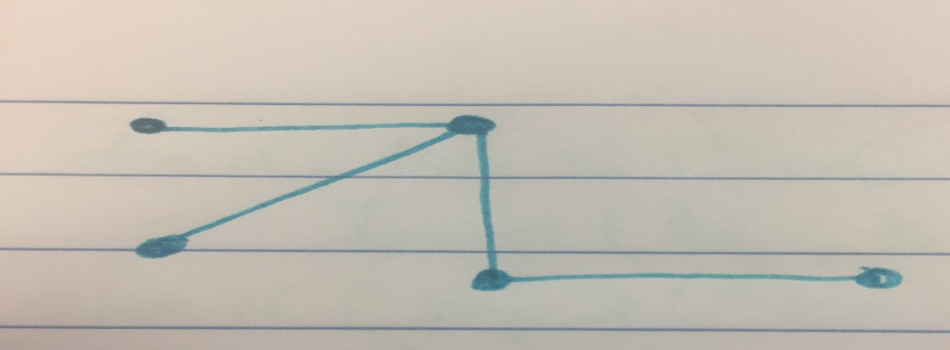

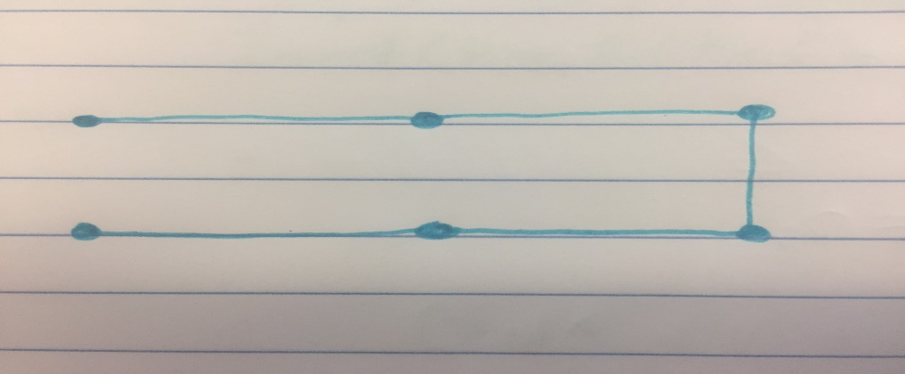

2. n – 1
3. n – 1
4. n – 1

2)

1.) $\sum_{i=1}^{n}{\left(cost\left(AllFrom\right)+a_{1}\right)}$

$cost\left(AllFrom\right)= θ(n)$

2.) $cost\left(AllFrom\right)= θ\left(n\right)$

$\sum_{i=1}^{n}{\left(θ\left(1\right)+a_{1}\right)= θ(n+a)}$

3)

1. for u ← 1 to n

for v ← 1 to n

A’(u,v) ←0

for i ← 1 to 0

edges ← A Allfrom(i)

foreach( e $∈$ edges)

k ← target of e

$$θ(n^{2}+\sum_{i=1}^{n}{(n+a_{1}))= }θ\left(n^{2}+ n^{2}+ a\right)= θ(n^{2})$$

$\sum_{i=1}^{n}{\left(u_{1}+ θ\left(1\right)\right)=θ(n+a) }$